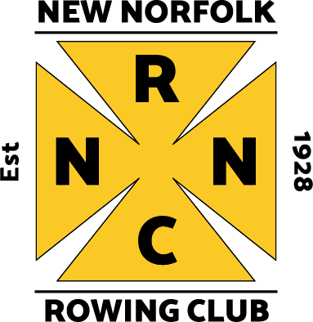
NNRC Photographic Highlights

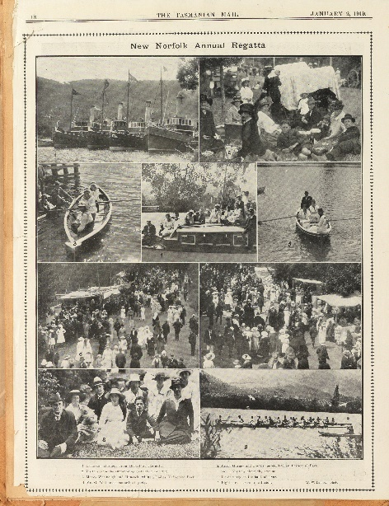

1918: Scenes from the New Norfolk Regatta Association Annual Boxing Day Regatta, Tasmanian Mail.

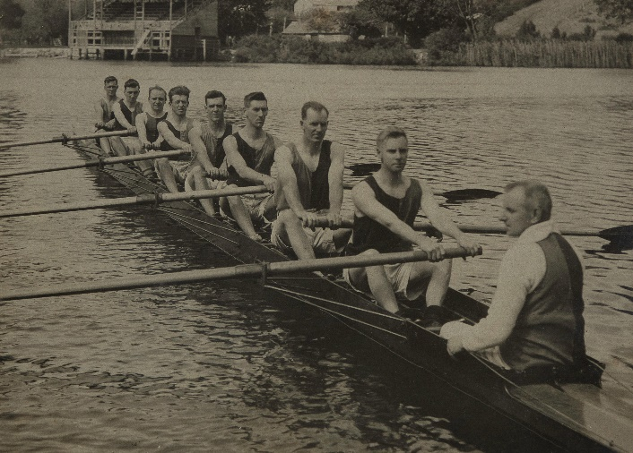
1929 December 26: The Hon. LM Shoobridge, MLC presented the NNRC Maiden Eight crew: E. Young (bow), J. Turner, M. Flynn, R. Doran, D. Triffett, H.I Johnston, P. O’Keefe, A.T. Shelton (stroke) & coxed by T. Crooks with a silver cup on the occasion of their first win in the new boat “Fitzpatrick”.

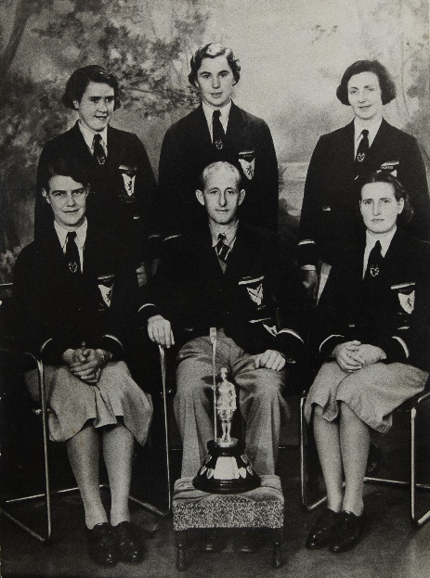

1940: NNRC Women’s crew: B. Young (stroke), Maisie Doran, Eileen Russell, Elvie Lawler (bow), coxed by Tom Darcey, represented Tasmania in the Interstate Rowing Championships in South Australia in the Women’s Coxed Four. They were victorious in the race and took out the Ulva Trophy.

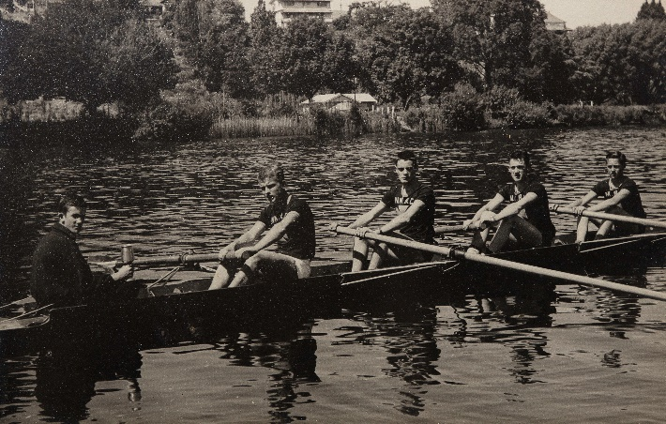
1961: NNRC Men’s Light Weight Coxed Four crew of Manfred Knuth (Str), Cliff Hutton (3), Tony Timbs (2), Terry Philpott (Bow), coxed by Joe Howlett, coached by Anthony Timbs won the Kirby Cup. This crew along with Emergency Kerry Hay represented Tasmania in the 1962 Penrith Cup at the Interstate Championships at Lake Windoree, Victoria.

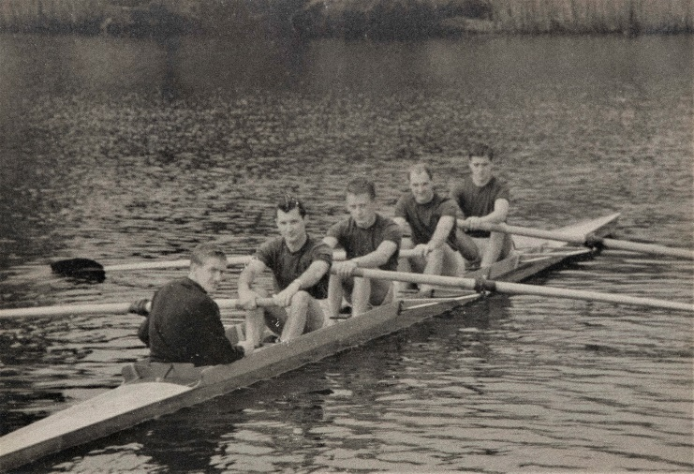
1965: NNRC Champion Lightweight Junior Four was stroked by Noel Browning with Robbie Dixon, Geoff Nichols, Terry Philpott, coxed by Daryl (Aly) Cashion and coached by G. Brooks. The Crew won the Men’s Lightweight Four races at the NNRC, Franklin, Lindisfarne, Southern Tasmanian Rowing Assoc., Royal Hobart, Glenorchy, Tamar & Devonport Regattas as well as the State Championship over the season.

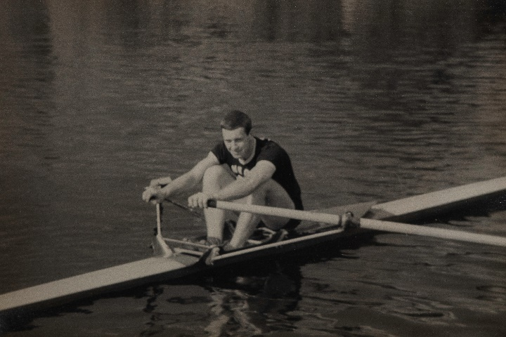
1967: NNRC Sculler John Moore won his fifth Tasmanian Men’s Single Sculling Championship in a time of 5.45 min on the River Tamar ahead of Ian Winter (Buckingham) and Paul Harvey (Lindisfarne). That year Moore also won the Open Single Sculls at the Derwent, Southern Tasmanian Rowing Association, NNRC, Shipwright’s Point Regattas. In 1964 and 65, John Moore won the Open Scull at the Tasmania Championships. He represented Tasmania in two President’s Cup Races at King’s Cup Regattas.

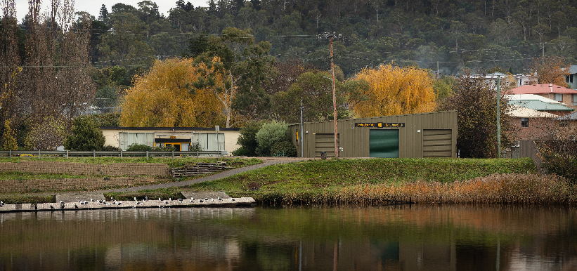
The home of the New Norfolk Rowing Club was 44 Rocks Road from 1928 to 2020. The clubroom was built by NNRC volunteers and opened in 1978. The Shed was a wooden fruit shed until 1988 when a steel frame was fabricated around it. When steel cladding was finally secured, the old structure was pulled down from within. This was a mammoth task for NNRC volunteers. The NNRC moved to the Esplanade in August 2020.

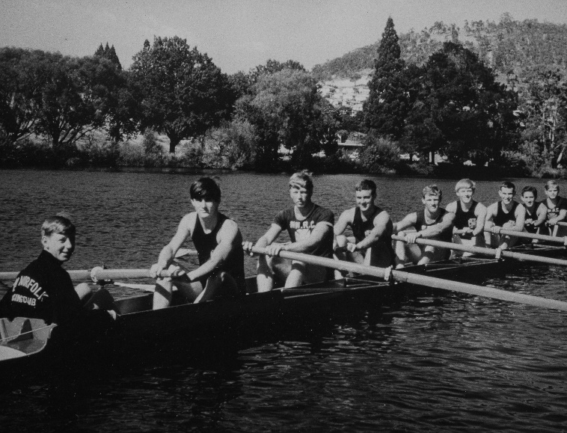
1968: NNRC’s Senior Eight, stroked by Dennis Ransley with Kerry Braslin, Roger Bently, John Windsor, Damien Rainbird, Robin Nossiter, Robin Oakley, and Kevin Williams in the bow were coxed by Woody Brown and coach by Terry Triffitt. This crew recorded a win at the Sandy Bay Regatta. This was the first win in NNRC history for a Senior Eight.

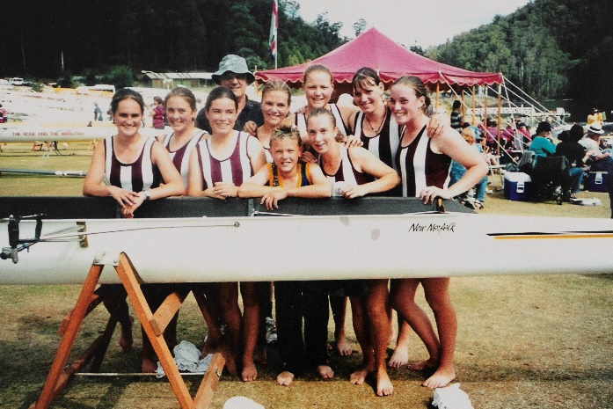
2000 March: NNRC/Ogilvie High School crew of Elisse McWhirter, Kathryn Webb, Colleen O’Brien, Jess Wade, Clare Harding, Rebecca Andrews, Alison Hornsey, Claire Plunkett, coxed by Luke Dancey was coached by Cliff Hutton to win the Under 16 Girls Eight at the Tasmanian Schools Championships at Lake Barrington. This was the first time that a state school crew won the trophy.

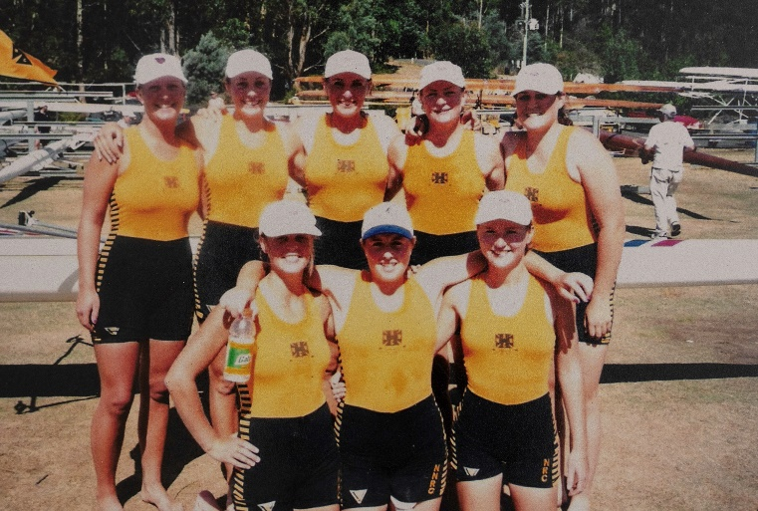
2000: NNRC Coach, Roger Drummond saw his crew of Georgie Wells, Claire Shields, Alice Ayliffe, Kate Hornsey, Jacqui Drummond, Jo Burbury, Sara Lange & Liz Weldon win the Women’s Under 23 and Women’s Senior Eight at the Tasmania Rowing Championships. This Senior Women’s Eight win was a first for NNRC.

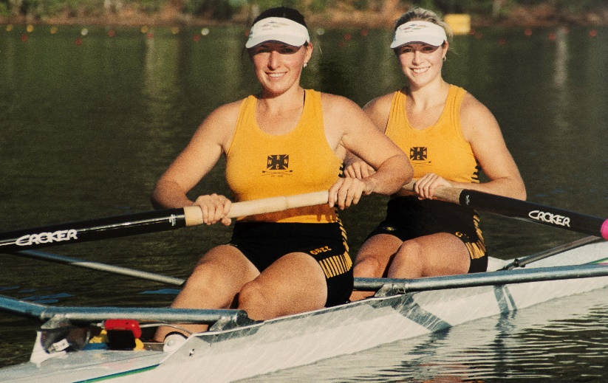
2003: NNRC won the first State Pennant in 75 years of competition, including 10 State Championships. Senior Oars women Kate Hornsey & Claire Shields won 17 Gold Medals between them. In 2003 Kate Hornsey & Claire Shield were selected to represent Australia in the Women’s U23 Four at the World Championships in Belgrade Yugoslavia and the Nations’ Cup in Lucerne Switzerland.

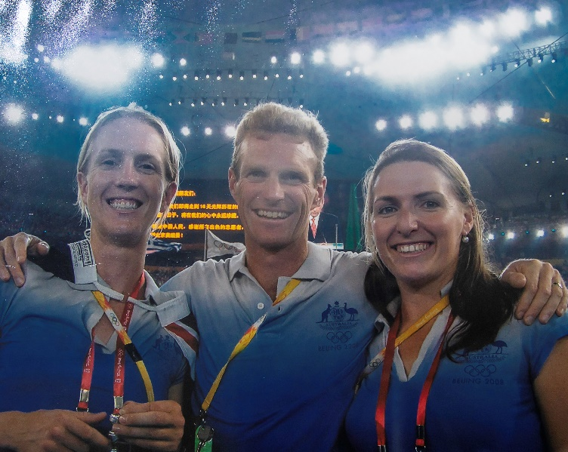

2008 August: NNRC’s Kerry Hore, Kate Hornsey & Anthony Edwards represented Australia at the Beijing Summer Olympic Games.

